**Objectives: Write servlet application to:**

**1. to print current date and time.**

**2. communicate between Html and servlet.**

**3. create an auto refreshed page.**

**Theory:**

**Servlet:**

**Servlet** technology is used to create a web application (resides at server side and generates a dynamic web page). **Servlet** technology is robust and scalable because of java language. Before Servlet, CGI (Common Gateway Interface) scripting language was common as a server-side programming language.

**Source Code:**

**1. to print current date and time:**

**//servlet.java file**

package com.innovator;

import javax.servlet.ServletException;

import javax.servlet.http.HttpServlet;

import javax.servlet.http.HttpServletRequest;

import javax.servlet.http.HttpServletResponse;

import java.io.IOException;

import java.io.PrintWriter;

public class servlet extends HttpServlet {

    public void processRequest(HttpServletRequest request, HttpServletResponse response) {

        response.setContentType("text/html;charset=UTF-8");

        PrintWriter out;

        try {

            out = response.getWriter();

            out.println(" <html>");

            out.println("<h1>The current date is: "+java.time.LocalDate.now()+"</h3>");

            out.println("<h1>And, the current time is: "+java.time.LocalTime.now()+"</h3>");

            out.println("</html>");

        } catch (IOException e) {

            e.printStackTrace();

        }

    }

    @Override

    public void doGet(HttpServletRequest request, HttpServletResponse response)

            throws ServletException, IOException {

        processRequest(request, response);

    }

    @Override

    public void doPost(HttpServletRequest request, HttpServletResponse response)

            throws ServletException, IOException {

        processRequest(request, response);

    }

}

**//index.html**

<html>

    <head>

        <title>Start page</title>

        <meta http-equiv="Content-Type" content="text/html" charset="UTF-8">

    </head>

<body>

<h2>My servlet page!</h2>

<form action="./api" method="GET, POST">

    <Button>Show current Date and Time</Button>

</form>

</body>

</html>

**//web.xml file**

<!DOCTYPE web-app PUBLIC

 "-//Sun Microsystems, Inc.//DTD Web Application 2.3//EN"

 "http://java.sun.com/dtd/web-app_2_3.dtd" >

<web-app>

  <display-name>Archetype Created Web Application</display-name>

  <servlet>

    <servlet-name>servlet</servlet-name>

    <servlet-class>com.innovator.servlet</servlet-class>

  </servlet>

  <servlet-mapping>

    <servlet-name>servlet</servlet-name>

    <url-pattern>/api</url-pattern>

  </servlet-mapping>

</web-app>

**Output:**

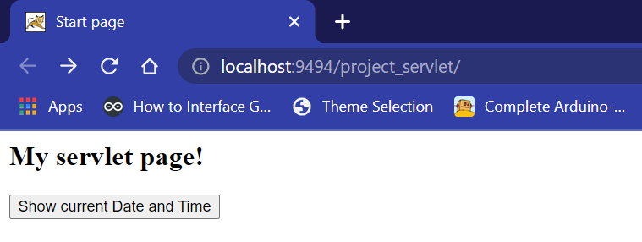

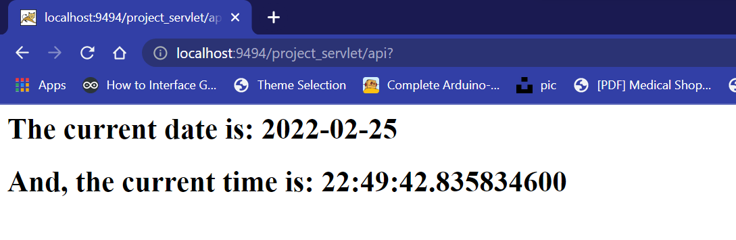

**2. communicate between Html and servlet.**

**//servlet.java file**

package com.innovator;

import javax.servlet.ServletException;

import javax.servlet.http.HttpServlet;

import javax.servlet.http.HttpServletRequest;

import javax.servlet.http.HttpServletResponse;

import java.io.IOException;

import java.io.PrintWriter;

public class servlet extends HttpServlet {

    public void processRequest(HttpServletRequest request, HttpServletResponse response) {

        response.setContentType("text/html;charset=UTF-8");

        PrintWriter out;

        try {

            out = response.getWriter();

            out.println(" <html>");

            out.println("<h1>Hello all from servlet</h1>");

            out.println("<h1>NewServlet at " + request.getContextPath() + "</h1>");

            String user = request.getParameter("user");

            out.println("<h2> Welcome " + user + "! to my servlet page."+"</h2>");

            out.println("</html>");

        } catch (IOException e) {

            e.printStackTrace();

        }

    }

    @Override

    public void doGet(HttpServletRequest request, HttpServletResponse response)

            throws ServletException, IOException {

        processRequest(request, response);

    }

    @Override

    public void doPost(HttpServletRequest request, HttpServletResponse response)

            throws ServletException, IOException {

        processRequest(request, response);

    }

}

**//index.html file**

<html>

    <head>

        <title>Start page</title>

        <meta http-equiv="Content-Type" content="text/html" charset="UTF-8">

    </head>

<body>

<h2>My servlet page!</h2>

<form action="./api" method="GET, POST">

    <label>Enter your name:</label><input type="text" name="user">

    <input type="submit" value="Click here">

</form>

</body>

</html>

**//web.xml file**

<!DOCTYPE web-app PUBLIC

 "-//Sun Microsystems, Inc.//DTD Web Application 2.3//EN"

 "http://java.sun.com/dtd/web-app_2_3.dtd" >

<web-app>

  <display-name>Archetype Created Web Application</display-name>

  <servlet>

    <servlet-name>servlet</servlet-name>

    <servlet-class>com.innovator.servlet</servlet-class>

  </servlet>

  <servlet-mapping>

    <servlet-name>servlet</servlet-name>

    <url-pattern>/api</url-pattern>

  </servlet-mapping>

</web-app>

**Output:**

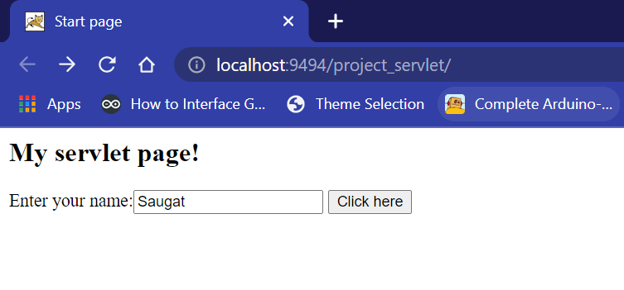

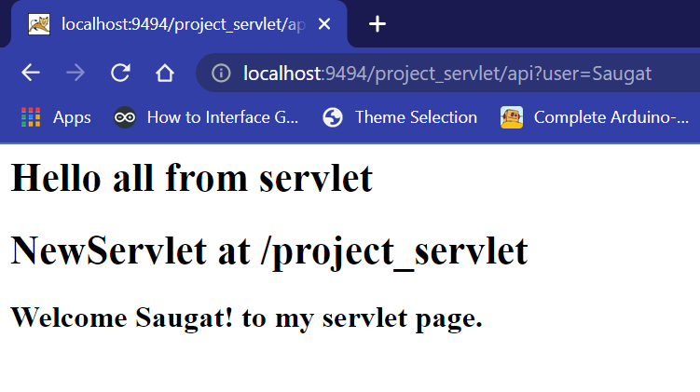

**3. create an auto refreshed page.**

**//Refresh.java file**

package com.innovator;

import javax.servlet.ServletException;

import javax.servlet.http.HttpServlet;

import javax.servlet.http.HttpServletRequest;

import javax.servlet.http.HttpServletResponse;

import java.io.IOException;

import java.io.PrintWriter;

import java.util.Calendar;

import java.util.GregorianCalendar;

public class Refresh extends HttpServlet {

    public void processRequest(HttpServletRequest request, HttpServletResponse response) {

        response.setIntHeader("Refresh", 1);

          // Set response content type

          response.setContentType("text/html");

          // Get current time

          Calendar calendar = new GregorianCalendar();

          String am_pm;

          int hour = calendar.get(Calendar.HOUR);

          int minute = calendar.get(Calendar.MINUTE);

          int second = calendar.get(Calendar.SECOND);

          if(calendar.get(Calendar.AM_PM) == 0)

               am_pm = "AM";

          else

               am_pm = "PM";

          String CT = hour+":"+ minute +":"+ second +" "+ am_pm;

        PrintWriter out;

        try {

            out = response.getWriter();

            out.println(" <html>");

            out.println("<h1 align='center'>Auto Refresh Page</h1><hr>");

          out.println("<h3 align='center'>Current time: "+CT+"</h3>");

            out.println("</html>");

        } catch (IOException e) {

            e.printStackTrace();

        }

    }

    @Override

    public void doGet(HttpServletRequest request, HttpServletResponse response)

            throws ServletException, IOException {

        processRequest(request, response);

    }

    @Override

    public void doPost(HttpServletRequest request, HttpServletResponse response)

            throws ServletException, IOException {

        processRequest(request, response);

    }

}

**//index.html file**

<html>

    <head>

        <title>Start page</title>

        <meta http-equiv="Content-Type" content="text/html" charset="UTF-8">

    </head>

<body>

<h2>My servlet page!</h2>

<form action="./Refresh" method="GET, POST">

    <Button>show autorefresh page</Button>

</form>

</body>

</html>

**//web.xml file**

<!DOCTYPE web-app PUBLIC

 "-//Sun Microsystems, Inc.//DTD Web Application 2.3//EN"

 "http://java.sun.com/dtd/web-app_2_3.dtd" >

<web-app>

  <display-name>Archetype Created Web Application</display-name>

  <servlet>

    <servlet-name>Refresh</servlet-name>

    <servlet-class>com.innovator.Refresh</servlet-class>

  </servlet>

  <servlet-mapping>

    <servlet-name>Refresh</servlet-name>

    <url-pattern>/Refresh</url-pattern>

  </servlet-mapping>

</web-app>

**Output:**

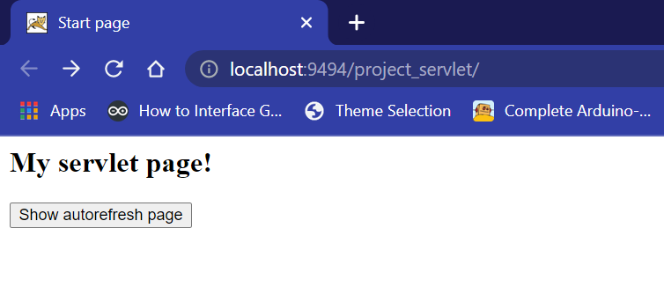

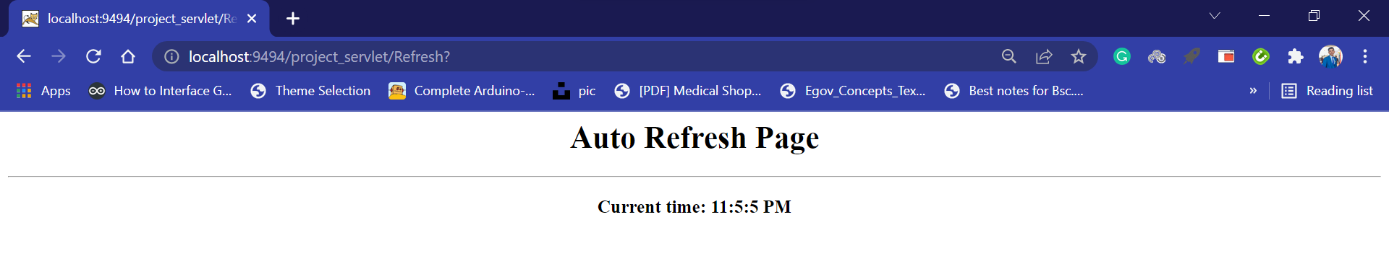

**Conclusion:**

In this lab of Advanced Java Programming, we successfully implemented the concept of servlet using Maven and Tomcat server in visual studio code.